|  |  |  |
| --- | --- | --- |
| INTELLIGENT NOTIFICATION BASED ON DATA ANALYTICS to reduce and achieve ZEro waste of consumable products | Location: | GITHUB |
| Date: | 26/04/2023 |
| Time: | 9:30 a.m. |
| Facilitator: | ROHIT GUPTA |
|  |  |
|  |  |

**ABSTRACT:**

Generally, we buy consumable products and stock them for usage in the future but sadly forget to use it. Since, these products come with a shelf life and expire after a time which leads to wastage. My solution helps the product companies to remind their consumers to consume the product in advance before the shelf life ends and order the same in advance so they have it when they need it. This shows the customer that the product company cares about their investment and leads to improve the relationship between the customer and the product company. The customers trust the product company even more and become a loyal customer and increasing sales.

As we know a lot of efforts is invested in the backend from start of the process – gathering the raw material to making a finished product. Optimum utilization and zero wastage are the best way of valuing and showing respect to all the efforts made in the hindside. This is also a way to move towards a sustainable future.

1. Requirement

Gather Customer Information, Sales Transaction Information and Product Information.

**Table 1**

|  |
| --- |
| **Customer Info Table** |
| Customer ID |
| Customer Name |
| Customer email ID |
| Customer Mobile No. |
| Customer Type |

**Table 2**

|  |
| --- |
| **SALES Transaction Info Table** |
| Sales Transaction ID |
| Transaction Date |
| Customer ID |
| Product ID (SKU) |
| Quantity |
| Batch Number |
| Manufacturing Date |
| Expiry Date – (Calculate if info not available) |

**Table 3**

|  |
| --- |
| **Product Table** |
| Product ID (SKU) |
| Product Name |
| Description of Product |
| Product category |
| Batch Number |
| Price |
| Net Quantity – (100 ml, 15gm ) |
| Manufacturing Date |
| Recommended Usage – (1ml, 1g etc.) |
| No. of Servings – (Calculate if information not available) |
| Expiry Date – (Calculate if information not available) |
| Stock Status – (Sold, in store, in hub, in manufacturer’s inventory, being manufactured) |

1. Map the tables

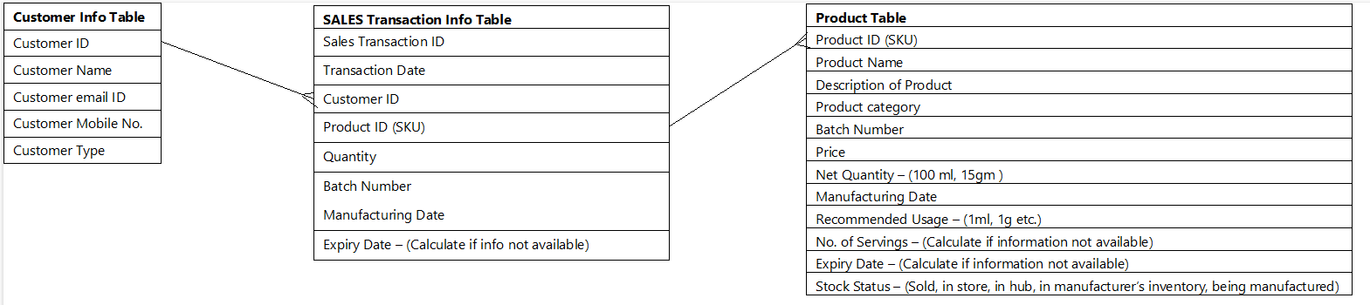

This will give the information about a customer’s purchase activity.

1. Analysis

Check for each SKU if the last unit sold to the customer is about to expire in 30 days.

1. Call to order

If yes, send notification to the customer via email, SMS & Push notifications on App and website to place the order and recommend to use the product before the shelf life comes to end. The product company can mention about how they value the consumers investments in the product and may be educate them about how this helps in reducing wastage.

1. Request Customer Feedback.

Request Customer for feedback if they liked this advance notification service and how was their experience and check if they would like to receive similar notifications for other products. Also, recommend to register the other products whenever they buy it from 3rd party sources.